CIVET High level design

DOC. No.: | REV.: 00 |  |  | PRODUCT: CIVET
TITLE: CIVET High level design |  |  |  | Project:
Prepared by: | Donald Huang |  |  | Date: | 2/3/2008
Remark: | Approval:
Remark: |  | Department | Title |  |  | Signature
Remark: | 1 | Electronic R&D
Remark: | 2
Remark: | 3 | QA
Remark: | 4 | GM

Revision | Description of Change | Author | Date
00 | Initial version | Donald Huang | 2/3/2008
01 | Adjust implementation phases | Donald Huang | 3/27/2008
02 | Add vending system overview and change new software structure configuration part | Donald Huang | 4/24/2008
03 | Change system graph, UI design | Donald Huang | 5/8/2008
04 | Change IO/main board design  Remove implementation phases | Donald Huang | 11/6/2008
05 | Update CIVET software architecture. | Donald Huang | 2/19/2009
06 | Replace by CIVET | Donald Huang | 2010-08-27

1 Overview 4
1.1 Purpose 4
1.2 Scope 4
1.3 Reference 4
1.4 Abbreviations 4
1.5 Overview 4
2 History 5
2.1 Slim Line software 5
2.2 Vending system overview 5
2.2.1 Configurator 5
2.2.2 Online tools 6
2.2.3 Machines 6
2.2.4 Back office system 6
2.3 SL software implementation 6
2.4 GVMC 7
2.4.1 UI 9
2.4.2 Admin 9
2.4.3 Payment 9
2.4.4 Other modules 9
2.4.4.1 DBH & DBL 9
2.4.4.2 BUS & GWY 10
2.4.4.3 GEH & SUH 10
2.4.4.4 VEH 10
2.4.4.5 CLH 10
2.4.4.6 IOH 10
2.5 SVMC 11
2.5.1 SVMC on I/O board 11
2.5.2 Sub boards 11
2.6 CLServ 11
2.7 AT designer 12
2.8 Menu builder 12
2.9 Other software 12
2.9.1 Boot loader 12
2.9.2 HexToBin 12
3 CIVET software architecture 13
3.1 Overview 13
3.1.1 Machines 14
3.1.1.1 I/O board application 14
3.1.1.2 Small board application 14
3.1.1.3 Main board application 15
3.1.1.3.1 Overview 15
3.1.1.3.2 VendStateMachine 15
3.1.1.3.3 SupervisorStateMachine 15
3.1.1.3.4 UI 16
3.1.1.3.5 Adm 16
3.1.1.3.6 Credit 16
3.1.1.3.7 System Services 16
3.1.1.3.8 Machines 17
3.1.1.4 Boot loader 17
3.1.2 Configuration tools 17
3.1.2.1 Service Tool 17
3.1.2.2 Machine designer 17
3.1.2.3 Menu Editor 17
3.1.3 Back office system 18

Overview

Purpose
The purpose of this document is to describe the Spengler new software architecture – CIVET.

Scope
The scope of this document is the design description of all software in the CIVET, including software for: I/O board, cup dispenser board, main board, UI, PC, etc.

Reference
- SL15 SW Function Requirement, David, 2008
- Old SL source code (75388,75360,75395,AT designer)
- HLD GVMC DL&CL, Ronald Gram, 2000
- SRS GVMC CL 12, Ronald Gram, 2000
- FB200_analysis, Paul Monnee, 2000
- S-Line Brief.ppt, Martien Kuypers
- 10011656_01_Operating_Instructions_SL_Tabletop.2005.06.13.pdf
- sl25 ui.doc
- Multiple PCB global design.doc, Michel van Bergen, 2001
- HLD GEH 002.doc, Michel van Bergen, 2001
- HLD VEH handler.version1.0.doc, Michel van Bergen, 2001
- New SL Range Schedule 20080110_David.mpp
- SVMC software improvement.doc
- Component Migrate to IO Board Proposal.doc
- CIVET VMC SW Requirement.doc
- EVADTS_6-1.pdf

Abbreviations
- SW Software
- HW Hardware
- ME Mechanical
- HLD High level design
- SRS Software Requirement Specification
- GVMC General Vending Machine Controller
- SL Slim Line (a Maas vending machine serial)
- DL Design Line (an old Maas vending machine serial)
- CL Customer Line (an old Maas vending machine serial)
- VM Vending Machine
- MDF Machine Definition File
- IPD Ingredient Product Definition

Overview
The following document can be divided into several parts:

- History: describe the SL software
- CIVET software architecture

History

Slim Line software
Maas vending machines are divided into 3 serials: Design Line (DL), Customer Line (CL) and Slim Line (SL).

Vending system overview

Configurator

- Recepture
- Products
- Storage
- Preparation
- Machine definition
- Menu

Back office system

- pricing
- reporting

Machines

Online tools
Update configuration
Update software
Debug

Figure 1

The vending system software is constructed by 4 major parts which as list below.

Configurator
Configurator is series of software that define the appearance, behaviours of machines.

The configuration of a machine includes:
- Machine definition: The working parts of machine are defined as logical components. Many components working together build up a machine. The machine definition defines what components in a machine and how they cooperate with each other (connections). The machine definition also defines the components’ basic adjustment parameters.
- Products: What products a machine can produce. Inheritances between products (e.g. Coffee milk can “inherit” the recepture/preparation of coffee-black).
- Recepture: The composition of the product
- Storage: Physical locations of the used ingredients in the machine.
- Preparation: The acting sequence of components, such as number of required (separated) fluids and their mutual order.
- Menu: Define the user menu of the user screen.

Online tools
Online tools connect the machines to update and monitor machines. The major functions for online tools are: update configuration, update software, debug.

Machines
Machines are the vending machines. Software in machines will be described in the next section.

Back office system
Back office system is a third party system that defines the product prices and gathers machines’ vending information.

SL software implementation

The CIVET software is developed basing on the SL software. The SL software is running stably for years. Many software components, like: EVA, BOS, CRH, CRD, etc., are essential for all systems. And many new features the CIVET software must support.

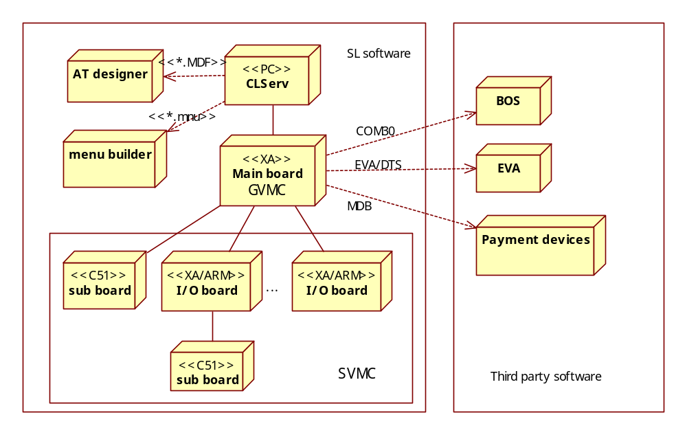
Figure 2

Figure 2 is the SL software deployment graph.

Abbreviation:
- BOS Maas Back Office Service
- EVA European Vending Association
- COM30 BOS protocol
- EVA/DTS European Vending Association – Data Transfer Standard
- MDB Multi-Drop Bus, standard payment devices protocol
- GVMC Generic Vending Machine Controller
- SVMC Specific Vending Machine Controller

The whole system is constructed by following software:
- GVMC: main board software, handle most things: UI (keyboard input, LCD output both for operator, user and developer), back office system (BOS, EVA), payment devices, vending issue, etc.
- SVMC: I/O board and sub broad software, control hardware (motors, sensors, etc.) to produce product.
- CLServ: a PC based software for debug and software download.
- AT Designer: generate configuration files for SVMC
- menu builder: generate menu file for GVMC UI

To communicate with BOS and EVA, use third party offline data collection software.

Each system must have one master machine which has main board and one or more slave machines which have I/O boards or sub boards. Software for main board is called GVMC, for I/O board is called SVMC. There are some utility software for debug, download and configuration.

Software in figure 2 is corresponding to logical parts of figure 1. They are:
- Configurator: AT designer, menu builder
- Online tools: CLServ
- Machines: GVMC, SVMC
- Back office system: Third party software

GVMC
GVMC (main board software) handle most things: UI (keyboard input, LCD output both for operator, user and developer), back office system (BOS, EVA), payment devices, vending issue, etc.

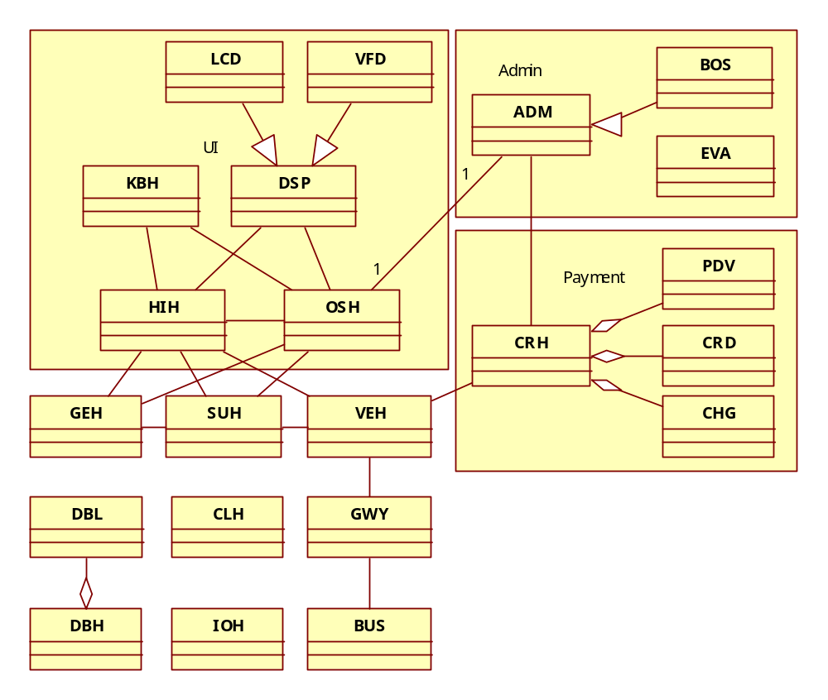
Figure 3

Figure 3 describes the modules in GVMC. Though the GVMC is written by C not C++, but it work as classes. Each module, in GVMC handler, can be treated as a class. The modules can be described using a class graph.

In SL software, each module could provide an application level debugger controller at the same time for debugging using CLServ. The debuggers are not shown in the graph.

Modules abbreviation:
HIH Human Interface Handler
DSP Display
LCD LCD
VFD VFD a kind of LED display, with 2 lines up to 10 characters each line.
KBH Keyboard Handler
OSH Operator Service Handler

ADM Administration
BOS Maas Back Office Service
EVA European Vending Association

CRH Credit Handler
PDV Payment Device
CRD Card, for credit card reader
CHG Changer, for cash

SUH Supervisor Handler
VEH Vending mode Handler
CLH Clock Handler
GEH General Error Handler
GWY Gateway
BUS Bus
DBH Database Handler
DBL Database with Language
IOH I/O Handler

There are 3 functional groups of modules: UI, Admin and Payment

UI
The core of UI is HIH. HIH control all input/output messages for human interface.

LCD or VFD implements the DSP interface for display message. SL hardware’s UI output device is black and white LCD or a 2 lines VFD. For LCD, the SL software use Ramtex GLCD library for windows management. When HIH receive messages from OSH, SUH to display menu or from other modules to display message, HIH will forward these messages to DSP to display. Every module can send message to control display. This method is very flexible. But everybody, even modules do nothing about UI, knows the UI. It expands the dependency; make it harder for unit test, it also limits the UI’s implementation.

KBH receive keyboard input message and send it to HIH. In new CIVET, there is no keyboard and user uses touch screen for input. The touch screen message will be integrated into Windows messages. The KBH module can be removed.

OSH handles the operator menu; part of HIH handles the user menu. The operator menu is very complex. It integrates everything that need to display: maintenance UI, supervise UI, debug UI, etc. It has a very deep menu tree, adjustment is needed.

Admin
The BOS and EVA modules implement the same interface for two back office administration system. The system gets the price for each product before sell and accumulate turnover after payment system got paid.

The limitation for SL software is there can support only one system for each build, not both.

Payment
The CRH is the core of payment system. Each type of credit device has its own handler (CHG, CRD, PDV, etc.). These handlers all have specific knowledge about the credit device. For each credit device (changer, reader, etc.) a specific handler is started to handle the credit issues of that credit device.

The credit device handlers are controlled by the credit controller CRH. This module controls and coordinates all the credit device handlers. The HIH communicates with the credit controller module.

The payment is relatively fixed and need no change.

Other modules

DBH & DBL

DBH stores and read configuration, DBL handles language relative information.

In old SL software, the program handles different kinds of store media directly. Flash, EEPROM, RAM, etc. lots of storages make the DBH complex. In new CIVET, these media can be access by real file system through operating system. That will make it much simpler.

BUS & GWY

BUS implements Polltask protocol for messages over 485 between boards. GWY determine messages destination (local or remote).

With BUS and GWY, the SL software has the flexibility of deploying any module in any hardware boards.

GEH & SUH

All errors in the system are reported to GEH. If the reported errors are fatal a message is send to SUH. SUH switches the VM to fatal error mode. After SUH has switched to error mode HIH sends a request to GEH for an error report. As a response to this message all active fatal errors are send to HIH (text format).

The human interface is used to display the system errors/warnings. SUH determines to VM mode and two of these modes are used to display errors and or warnings.

If HIH is ready to display errors warnings he sends a display message to GEH. This puts GEH in display mode. In this mode all changes in the display are reported to HIH with a message with all active errors/warnings. The display mode is determined by HIH and send to GEH. The following modes are implemented:

- Show warnings. This mode is send if the VM is in SPECIAL VENDING mode.
- Show fatal errors. This mode is send if the VM is in OUT OFF ORDER mode.
- Show fatal errors and warnings. This mode is send if the VM is in OUT OFF ORDER mode and the door is opened.
- End display errors/warning mode.

If a new error/warning is reported or an error/warning is solved a message with a new list of error/warning texts is send to HIH.

Display mode commands trigger this function (send error/warning list) as well.

VEH

The vending mode handler is in control if the VM is in (special) vending mode (make a product and handle money). All vending operations are controlled by the vending mode handler.

CLH

CLH handles long interval timer.

IOH

IOH handles main board IO, like door, infrared.

SVMC

SVMC on I/O board

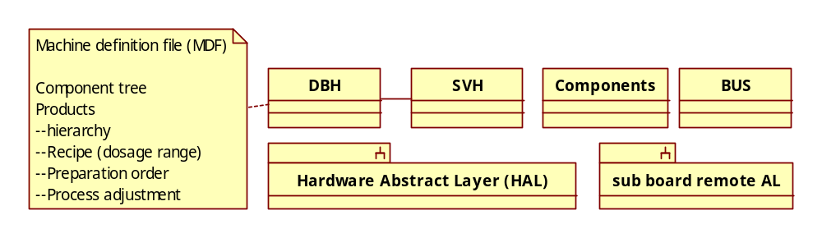
Figure 4

Modules abbreviation:
SVH Specific Vending handler
AL Abstract Layer

The SVMC controls hardware. DBH read machine definition information from a file called MDF. Then SVH can use the information to build products. The SVMC communicate with GVMC through BUS.

SVH controls hardware using program called Component. Each Component controls one or more hardware (motor, sensor, etc) to implement a logical component which corresponds to one component in MDF. SVH controls components with a unified component interface. The component may be located in I/O board or sub board connected to I/O board through 485. Component can control hardware through Hardware Abstract Layer locally and remote abstract layer remotely.

The SVH must know the component running order and dosage to build the product. Before a product start to vend, SVH use component tree and recipe information in MDF to build a connection tree for the specific product. Then use components to build the product with this connection tree.

Sub boards

The sub board application only provides low level I/O abstract layer and some simple warp of it. The SVMC components or main board will ask the sub board application to do jobs.

Sub board sometimes connects to I/O board (cup dispenser board), sometimes connects to main board directly (CCD5 keyboard).

Sub board usually run only C51 chip set, with limited resource. It can not do complex job. Sub board usually only provides low level hardware abstract layer and some simple wrapper.

CLServ

CLServ is a PC based tool for all boards’ software update, configuration and debug.

- Software update: CLServ can reset and download new board binary files to update software.
- Configuration: CLServ can use file transfer to download/upload configuration files.
- Debug: In SL software, each module could provide an application level debugger controller for debugging using CLServ command prompt environment.

CLServ use a USB cable to connect to main board, and maasserial driver need to be installed.

AT designer

AT designer is a MDF file editor on PC.

Menu builder

Menu builder is a main board menu file editor. It can edit and map a menu entry to a product.

Dbfx4 is a terminal style menu editor. Dbfx4 is an old program. A useful function of Dbfx4 is that it can edit menu entry which lines number is bigger than 10. That’s a tricky way to hide some menu entries.

Other software

Boot loader

Every board has a boot loader for hardware and software initialization; update software is another major function for boot loaders.

HexToBin

In board software, the application software will be placed in address after the boot loader. The application binary will not run at the compiler origin address. HexToBin is to do the little address adjustment.

CIVET software architecture

Overview

To meet the CIVET software requirement and development time limitation, the new CIVET will mainly base on the old SL software.

Main improvements are:
- Rewrite everything
- Modern graphical UI
- Move IO board application’s complex part into main board

Main differences of software development are:
- Use synchronized operation when possible
- Use C++ and OO design when possible
- Test every part.
- Agile development
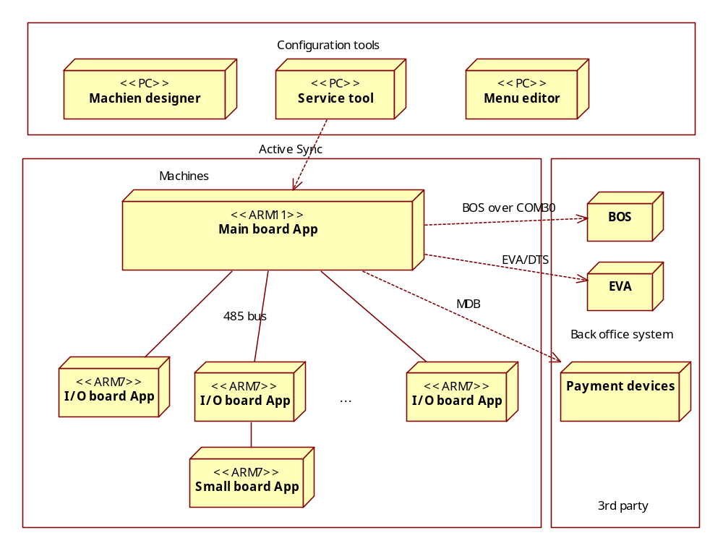
Figure 5

Figure 5 show the CIVET software deployment graph.

The vending system is divided in 3 major parts: Machines, Configuration tools and 3rd party software. From system structure point of view, there is no big difference between CIVET and old SL system. Every part has alternative.

Machines

The bus connection for CIVET has no changes. IO board connects small boards with separate RS485 bus. Main board use ARM11 chip set. For better software reuse and debug, all IO boards and small boards use ARM7 boards.

I/O board application
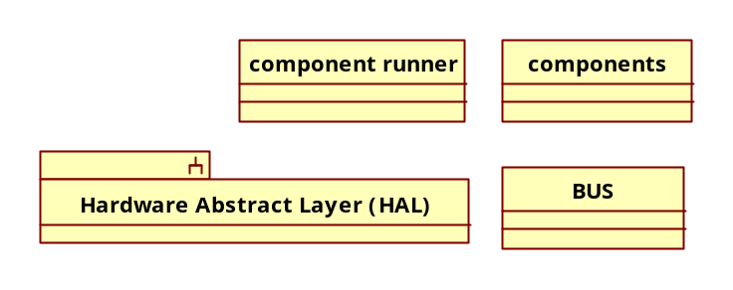
Figure 6

Comparing to figure 4, I/O board application will be much simpler for CIVET.
- All machine relative information will store in main board.
- Most of SVH including tree building, edit UI will be moved to GVMC

There are many advantages for this I/O board application change:
- Easier to develop and debug. Move most code to main board and PC, more powerful development tools, like Virtual Studio, ActiveSync, etc. are available. This makes development and debug much easier.
- Easier to test. By simplifying the I/O board application, the I/O board test will not need to setup the whole system.
- Easier to maintain. All board relative information are moved away from I/O board; when something goes wrong with I/O board, the maintenance man can just change the I/O board to fix it, not worrying about update information.
- Cost down. Less ROM and FLASH needed for simplified application.

There also have disadvantages:
- The main board configuration file will be complex. It will store many I/O boards’ configuration.
- For components moving, code and error handling must be redesigned.

Small board application
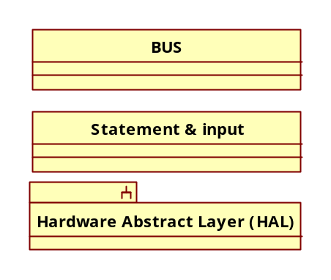

Small board has no big changes, small board has less ROM and RAM, only few commands (statement & input) are supported for small board.

Main board application
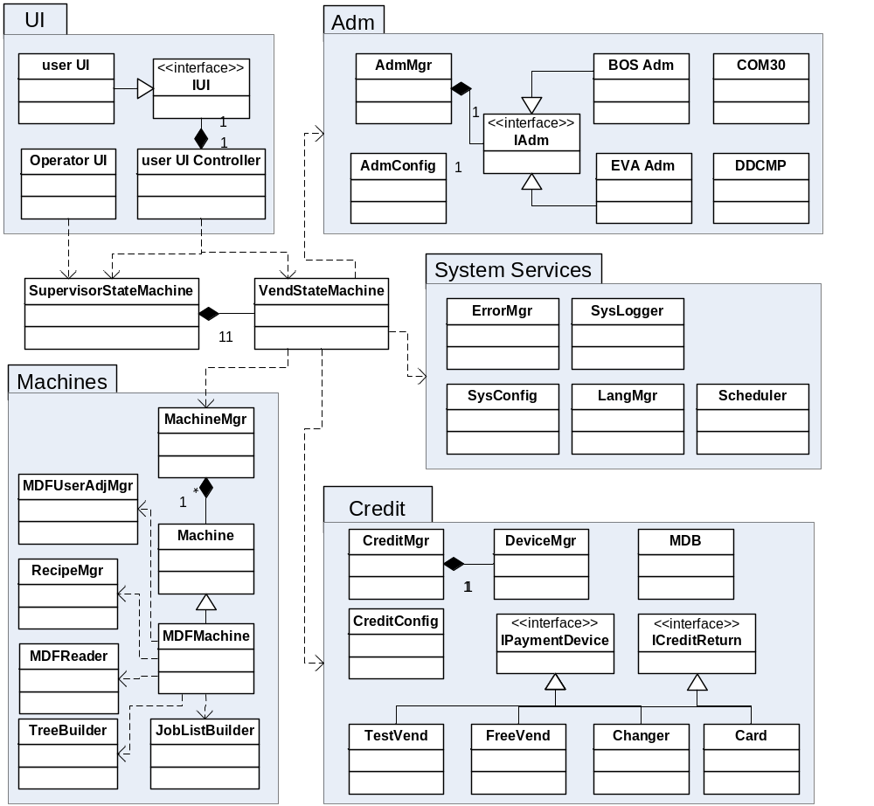
Figure 7

Figure 7 show the main board application structure. Main board application corresponds to SL GVMC software.

Overview

The main board application will run on Windows CE platform. All code will be redesigned using C++ and Object-Oriented method. Instead of Handlers which live in tasks which handle messages in asynchronous way, main board application in CIVET will mainly use objects (xxxMgrs) in synchronous way. It will be straight forward and easier for test and debug.

VendStateMachine

VendStateMachine previously VEH is the core state manager for vending process. It handles most business logic, e.g. MultiVend/SingleVend, Overpay take in, etc. Please see CIVET VMC SW Requirement.doc for reference.

VendStateMachine controls most GVMC modules.

SupervisorStateMachine

SupervisorStateMachine previously SUH is the core state manager for the whole machine. There are vending, maintenance, operator, shutdown, etc. states for the machine.

UI

UI previously HIH is the module handles user interface issue. The user interface can be divided into two parts: user UI (used by customer) and operator UI (used by operator).

User UI works in so called so call passive mode, using UI controller to switch different UIs. UI controller use IUI to control UI, different user UI implementation is possible by inherit from the IUI.

For better user interaction, operator UI will be customized for different machine: e.g. specific installation, specific parameter adjustment, etc. Operator UI works in so call active mode. Its major job is to read/edit/write some parameters.

Operator UI and user UI is switch by SupervisorMgr.

Adm

Adm is a module which manage back office (EVA and BOS) issues. Back office system can provide product price and collect vend data.

Different back office system implement IAdm interface. BOS adm implementation has more interface to provide BOS services, e.g. black list, price switch by time, etc.

AdmConfig manages configuration about Adm.

Data transmission modules are used for back office data collection. For BOS is COM30, for EVA is DDCMP

Credit

Credit module handles money issue.

CreditConfig manages configuration about payment devices and credit module configuration.

DeviceMgr manages payment devices. All payment devices derive from IPaymentDevice and ICreditReturn. FreeVend is a special payment device for vend without money. TestVend is a special payment device for operator testing product. Changer handles coin device including changer and acceptor (not refundable).

System Services

System services module provide isolated services for all other modules.

ErrorMgr previously GEH, manage all errors. Errors should be divided into many levels, error in different level will cause different UI message and log.

SysLogger is a global logger.

SysConfig stores machine configuration.

LangMgr previously DBL controls the multi language issue. Any module can retrieve string in current language. LangMgr can also switch language dynamically.

Scheduler previously CLH manages timer for background service like: rinsing, auto shutdown, etc.

Machines

Machines module manages services relative to IO boards. The previous tree building and SVMC DBH moved to this module.

MachineMgr supports all slave IO boards in the system.

Machine is the abstract class for all types of machine.

MDFMachine is the machine controlled by MDF machanism

MDFUserAdjMgr handles user defined adjustment data

RecipeMgr handles user defined recipe data

MDFReader, TreeBuilder, JobListBuilder do the build tree job.

Boot loader

The boot loader for I/O boards and small boards will remain the same functions. The boot loader for main board will rewrite and meet CE’s need.

In SL software, one of major function of boot loader is software update. This will be true for I/O boards and small boards. Main board’s software update will use specific main board update application instead of boot loader to update main board software.

Configuration tools

3 major configuration tools are alternatives for those in SL system

Service Tool
Service Tool is alternative for CLServ. Service tool connect to the main board with ActiveSync. It save the development of file operation (CLServ implemented them in COM30).

For 7 inch display main board application, service tool is an option for developers. All service tool functions can be implemented in operator menu of the 7 inch screen.

Machine designer
Machine designer is alternative for AT Designer. It edits the MDF file.

Menu Editor
CIVET Menu editor edit the menu description file that fits the graphical and Multilanguage supported UI.

Back office system
Back office system is the third-party software managing product price and turnover, etc.

